Setting up Twitter Conversion Tracking
Updated: January 4th, 2021
Execution Time: 15-30 minutes


Goal: To track your Twitter Ads conversions from inside the platform.

Ideal Outcome: You are able to see how many conversions your Twitter Ads campaigns brought you, and how much they are worth to you.

Prerequisites or requirements: Google Tag Manager needs to already be running on your website, if you haven’t already you can follow other SOPs available for Wordpress, Shopify, and Squarespace. You will also need a Twitter Ads account.

Why this is important: Seeing how many conversions and how much revenue each ad is bringing you, allows you to start optimizing your campaigns for the best results.

Where this is done: In Google Tag Manager and Twitter Ads Manager.

When this is done: Every time there is a new conversion or website that needs to be tracked inside Twitter Ads Manager.

Who does this: The person responsible for analytics, or paid advertising.

Environment setup

- Install the Twitter Pixel Helper extension for Google Chrome on your browser.


Generate your Twitter Universal Tag

- Log in to your Twitter Ads account here.
- Click Tools → Conversion Tracking
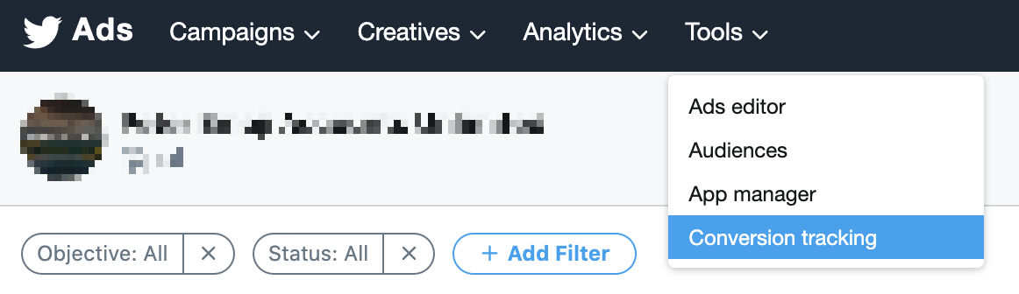
- You’ll be prompted to create a new website tag. Agree to the Terms and Conditions and click “Generate website tag for conversion tracking”

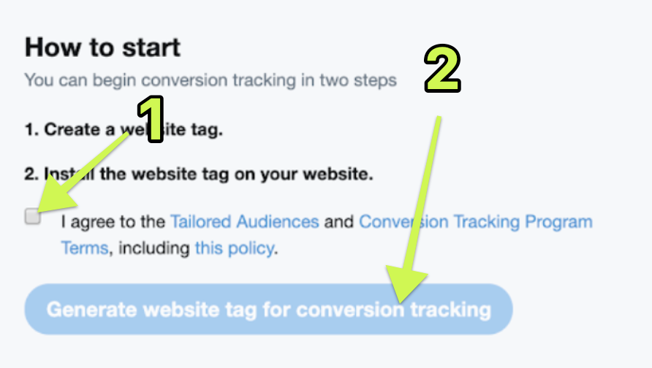

- You’ll get a piece of code like the one in the image below. Store it somewhere temporarily since you’ll need it for the next steps.
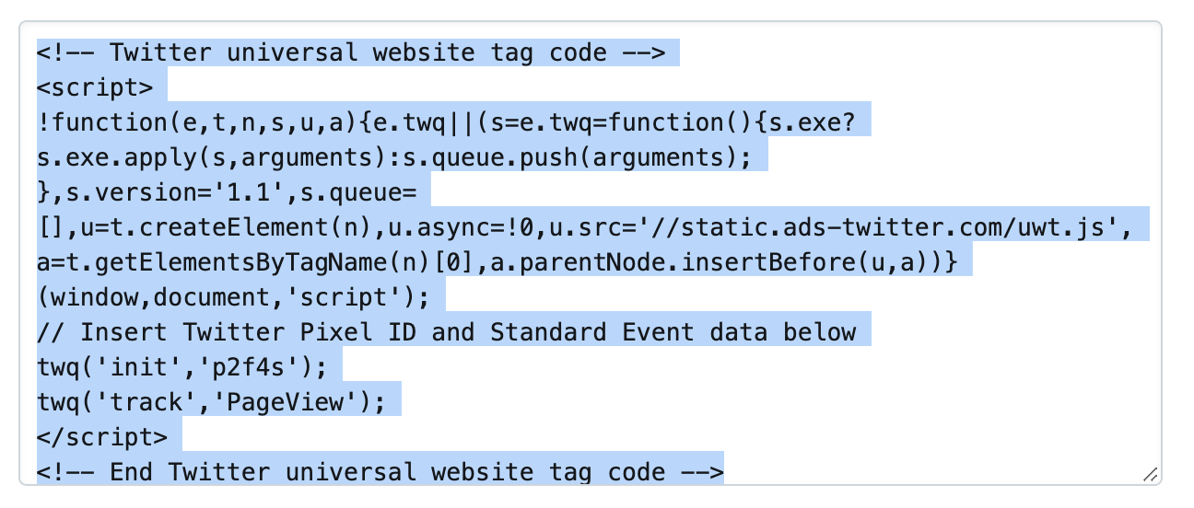

Install your Universal Website Tag using Google Tag Manager

- Log into Google Tag Manager here.

- Select the account that you want to use (the one that is being used on the site on which you want to install your tool):
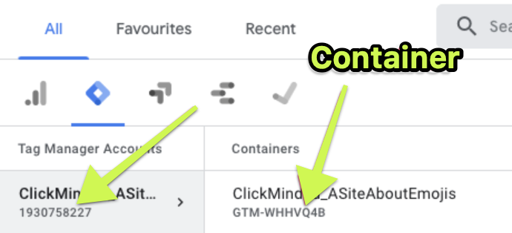
Note: If you’re not sure which container your website is using you can click the tag icon on your browser (assuming you have installed the Google Tag Assistant extension already)
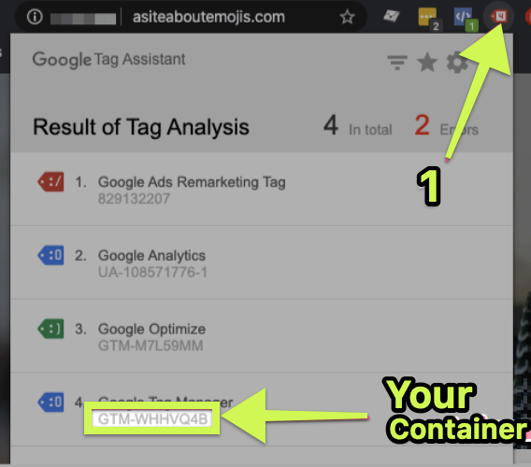

- Click Tags > New
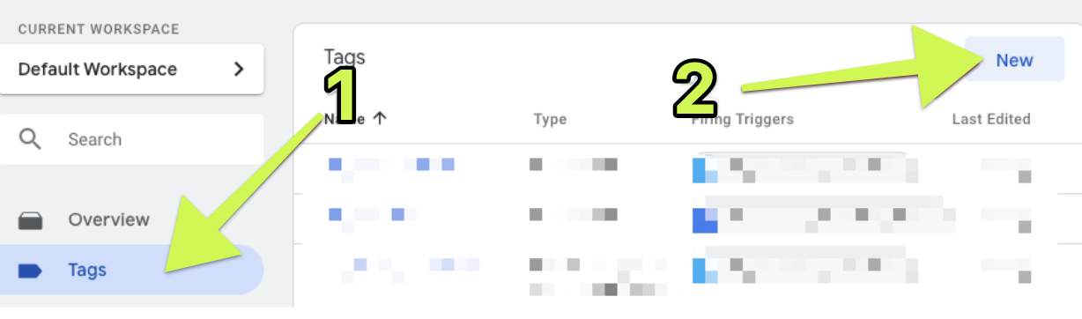

- Name your tag (give it a relevant name, for example: [Name of tool] - [Description]) and click anywhere in the “Tag Configuration” section:
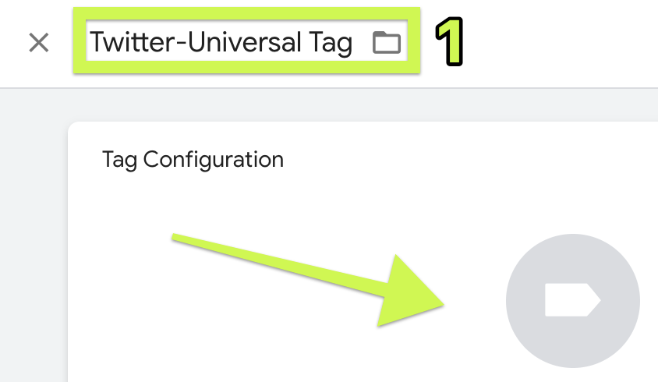

- Select “Custom HTML”:
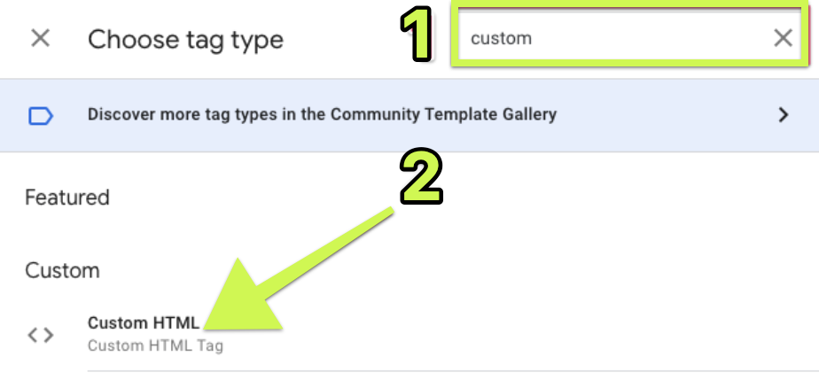

- Paste the code snippet that you retrieved from the first chapter of this SOP onto the HTML section:
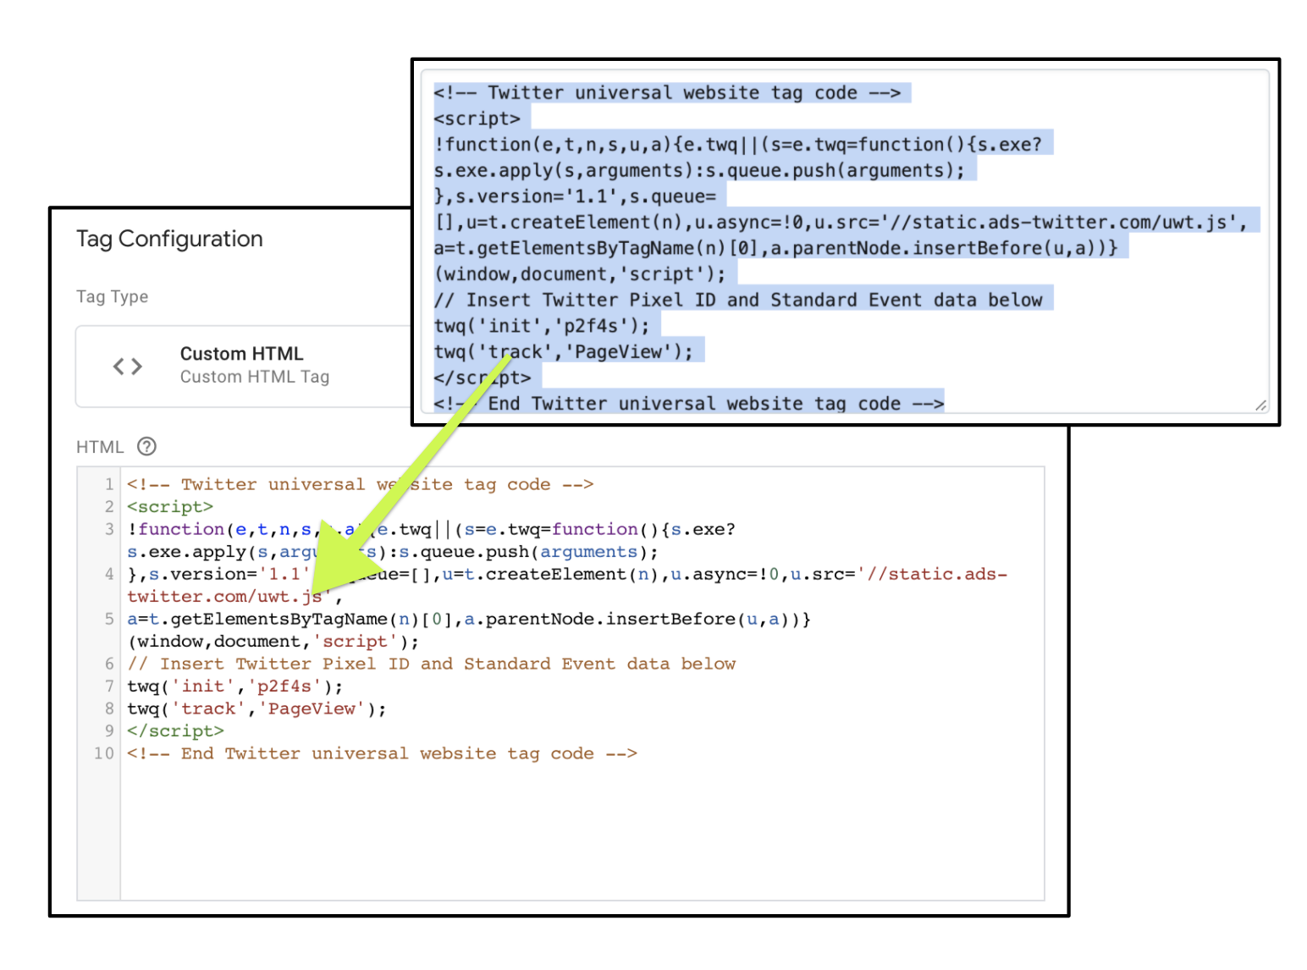
- Click “Triggering”:
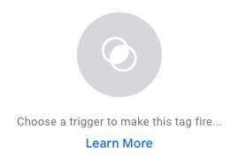
- There are two options now:
  - Select “All Pages” if you need the Twitter tracking to be on every page where Google Tag Manager is installed on. (This is the best option for 99% of the websites)

or

  - Click the “+” icon on the top right corner → Click the “Trigger Configuration” section → Click ‘Page View’ → Click “Some Page Views” → Click “Page Path” (Or Page URL) → Define the conditions where you want the code snippet to appear → Click ‘Save’.
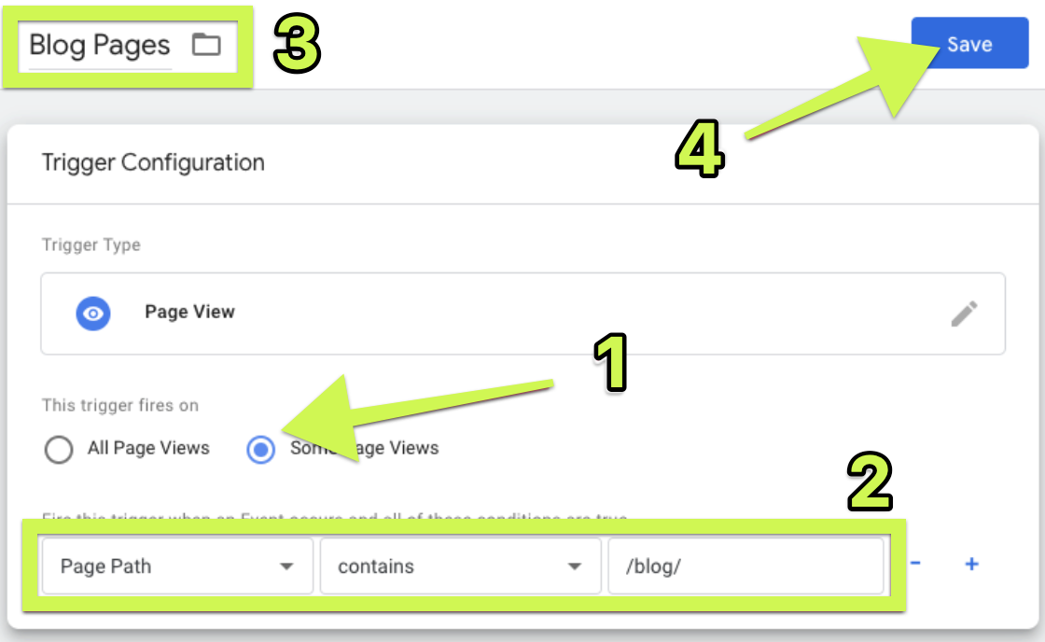

- Click ‘Submit’
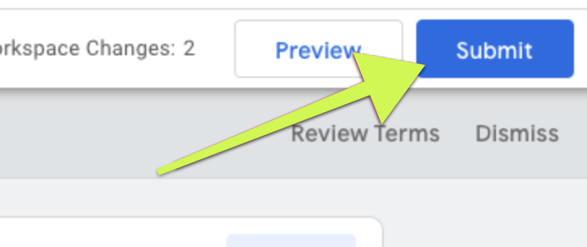

Determine the conversion events you want to track

- Pick the events you would like to track based on the purpose on the table below and whether you would use them to improve your Twitter campaigns:

- Site visit: User visits a landing page on your site
- Purchase: User completes a purchase of a product or service on your site
- Download: User downloads a file, such as a white paper or software package, from your site
- Sign up: User signs up for the advertisers service, newsletter, or email communication
- Custom: This is a catch-all category for a custom action that does not fall into one of the categories above. Source: Twitter
💡Tip: Most businesses only need to track Site Visits, Sign Ups and/or Checkouts.

Generate your Conversion Events
⚠️ Note: You’ll need to do this for every conversion event you defined in the previous chapter.

- Log in to your Twitter Ads account here.
- Click Tools → Conversion Tracking


- Click “Create New Conversion Event” in the top right corner:

- Setup the Conversion event that you determined in the previous chapter as such:
  - Name: Give it a relevant descriptive name since this will be the name that will show in your reports and inside Twitter Ads Manager.
  - Type of conversion: Select the one from the list that most closely relates to your conversion.
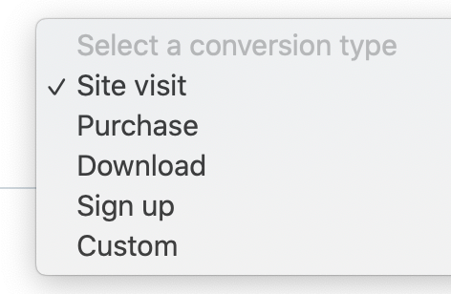
  - Website Tag: Select Universal Website Tag.
  - Traffic Conditions: Select the pages that are loaded when your successful event occurs, this is usually a “Thank You” page.

🤓 Example: Most e-commerce websites send users to a page thanking them for their order. This page could be found at asiteaboutemojis.com/thank-you or some other URL path, but it’s only shown to customers who have placed an order.

In this scenario if you want to track purchases for this website you would

- You will be asked for an Attribution Window. Set it according to the way you believe will result in more accurate reports for your business.

💡 What it means: The default values are 30-days for Post-Engagement and 1-day for Post View. This means that if someone only sees your ad (but does not interact with it, like clicking on it) and then goes on to purchase from you the same day through some other medium, that purchase will still be attributed to that Twitter Ad.

✓ Recommendation: Generally you’ll get more accurate reporting if you disable Post-View attributions. This means setting Post-View attribution to ‘Off’ (Instead of 1-day)

Verifying that your tag and conversion events are successfully setup

- Open your website using Google Chrome.
- Perform the required action to trigger your conversion.
  - e.g: Open your “Thank You” page, Submit your form, Click your add-to-cart button, etc.
  - Note: To test button clicks it’s better If in your keyboard you hold down the “Ctrl” (or “Cmd ⌘” key If you’re using a Mac) before clicking on the button that you want to track. This will make sure you will remain on the same page and therefore able to see if the event was indeed triggered.

- Click on the Twitter Pixel Helper extension for Google Chrome icon. You should see a message indicating A Twitter Website Tag was found. In addition you should see under the success message additional details about the parameters being sent.
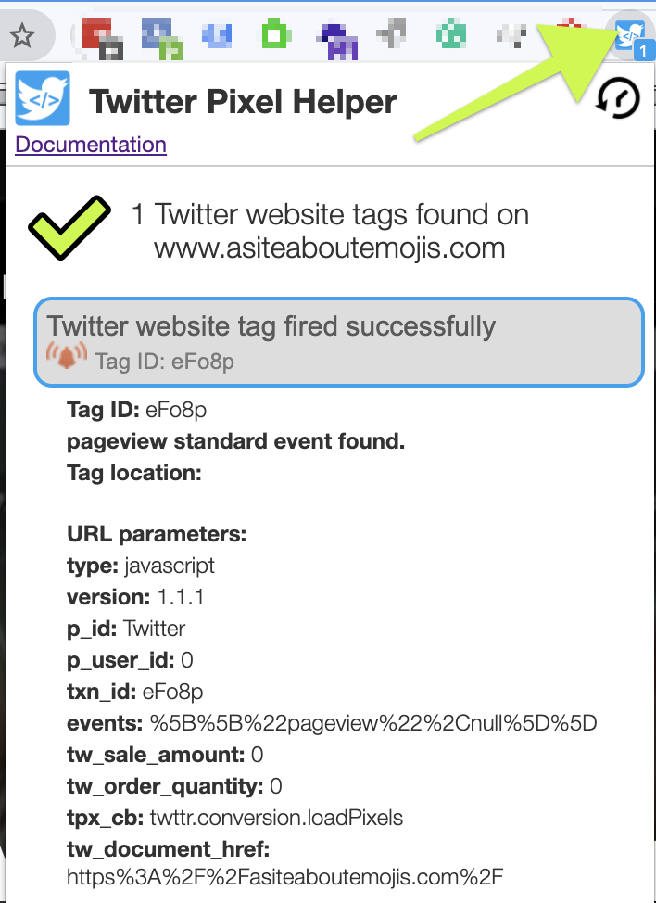

- Lastly, you’ll want to check your data is being received correctly by Twitter as well. To do that, on Twitter Ads Manager head over to Tools → Conversion Tracking and make sure under “Website Tag” for your events you are getting a “Tracking” status.

⚠️Note: If you get an “Unverified” status instead, make sure you have performed the action required to trigger your conversion on step 2 of this chapter. Note that the “Website tag” status might not update immediately, so you might have to also wait some time before it turns to tracking.

If you have correctly performed the steps to trigger that action and after some time it’s still not showing as “Tracking”, make sure you have completed all the steps of this SOP correctly. If you are still unable to get the status to “Tracking” you might need to contact a web developer as you might be experiencing a very particular issue.

